Nithin S
221IT085

IT150 Lab Assignment 6

1. Write a function which throws a division by zero exception and catch it in catch block. Write a C++ program to demonstrate usage of try, catch and throw to handle exception.

CODE

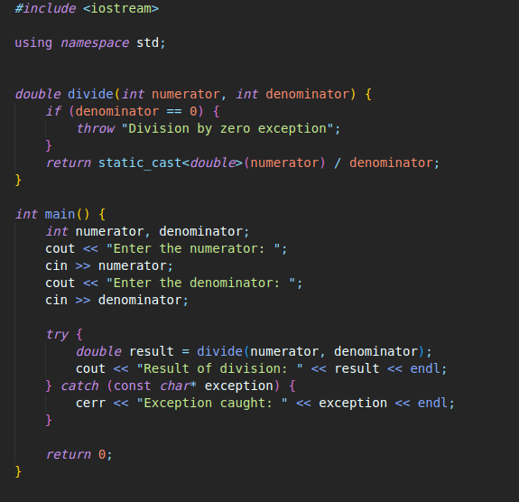
OUTPUT

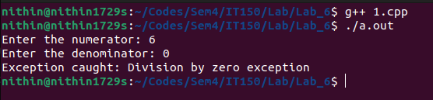

2. Write a Program to:
(i) Demonstrate the Catching of All Exceptions.
(ii) which handles array of bounds exception
(iii) implement the exception handling with multiple catch statements.
(iv) implement the exception handling with re-throwing in exceptions
(v) implement the exception handling with the functionality of testing the throw restrictions.

CODE

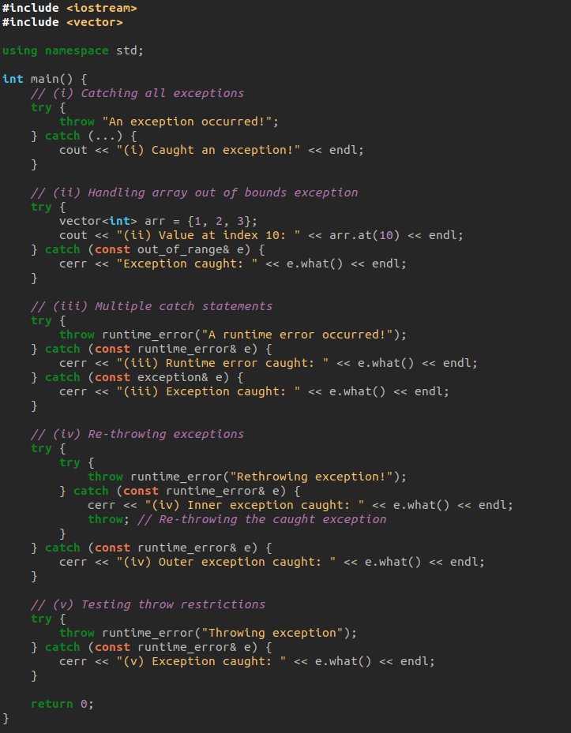

OUTPUT

